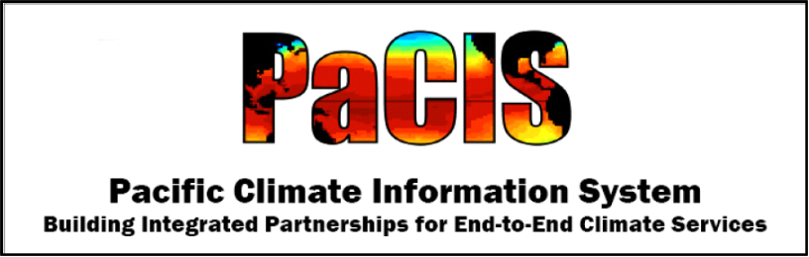
Towards a Pacific Climate Information System (PaCIS) Plan for Regional Climate Services: A synopsis based on outcomes of the March 22-24, 2011 PaCIS Steering Committee Meeting

Purpose
The National Research Council defines climate services as “A mechanism to identify, produce, and deliver authoritative and timely information about climate variations and trends and their impacts on built, social-human, and natural systems on regional, national, and global scales to support decision making.” ¹ Such information is essential to many aspects of policy, planning, and decision-making, and the demand for it is growing.

PaCIS provides a programmatic framework to bring together ongoing and future climate observations, operational forecasting services and climate projections, research, assessment, data management, outreach, and education – an integrated system of climate services – to address the needs of the Pacific Islands. It provides a forum for sharing the expertise, experience, and perspective needed to guide integrated program planning and product development.

This document follows from a meeting of the PaCIS Steering Committee and partners held on March 22-24, 2011 at the East-West Center in Honolulu. It outlines the elements of a plan designed to develop and deliver regionally-relevant products and services that further the PaCIS vision – “Resilient and sustainable Pacific communities using climate information to manage risks and support practical decision-making in the context of climate variability and change”. It is intended to form the basis for the formulation of more detailed plans that meet the demand from decision-makers in the Pacific Islands for ‘actionable’ information, the ultimate goal of climate services.

Background
PaCIS is composed of representatives of regional, national and local institutions and programs in the Pacific, as well as selected individuals from other regions, with experience and expertise in climate observations, science, assessment, education, outreach, users, and services (Figure 1). Consistent with the definition of climate services, the PaCIS mission includes the following objectives:
- Clarify climate information needs to guide climate education, outreach, user information needs, observations, products, services, research and assessment.
- Provide access to critical data, research and new climate information products and services.
- Translate research and assessment results into useful and usable climate information.
- Interpret global and regional climate forecasts and projections for local applications.
- Enhance regional and local capabilities to manage risks and support sustainable development in the context of climate variability and change.
- Enhance collaboration among national, regional and international institutions and programs involved in climate information services.

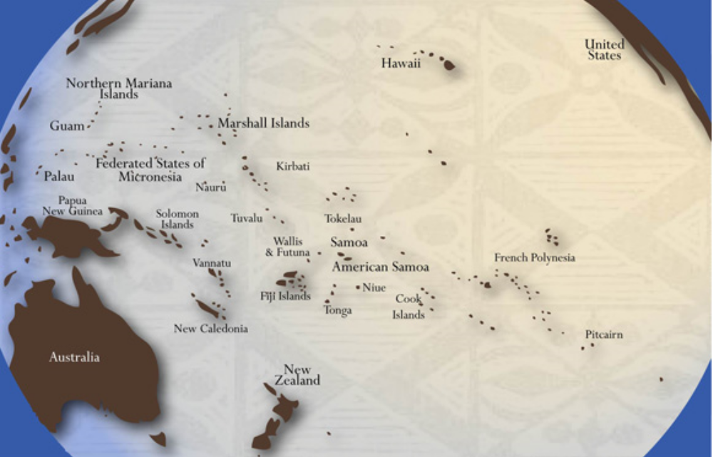Figure 1. The PaCIS Pacific. Adapted from the Secretariat of the Pacific Community's original map design by iWave Solutions, Inc. for the Pacific RISA, this map shows PaCIS’s primary geographic area of interest.

PaCIS and the concept of a Pacific Regional Climate Center trace their roots back to the 1997-1998 El Niño season and initial discussions of Pacific climate services at a workshop held in conjunction with the 1999 Pacific Regional Environment Program’s (SPREP) meeting of the Pacific Regional Meteorological Services Directors (RMSD). Between 1999 and 2004 a period of dialog ensued and many climate-related programs, systems, and organizations started activities in the Pacific or became more focused on climate-related issues. This period culminated with the Pacific ENSO Applications Climate (PEAC) Center First Decade Review workshop, held in June 2004 at the East-West Center in Honolulu, Hawaii, at which discussions among partners and users of PEAC resulted in the realization of a shared goal of a Pacific climate risk management information system. Eventually this led to the formulation of a PaCIS Steering Committee. The PaCIS Action Plan was completed by this group in February 2008. A meeting of the PaCIS Steering Committee and three working groups was held in Honolulu in August 2008. At this meeting there were lengthy discussions about actions needed to improve climate services in the Pacific. Ad-hoc discussions among members of these groups continued after meeting. This led to a gathering of 22 Steering Committee and working group members for an Implementation Plan Workshop in August 2010 and a meeting of the PaCIS Steering Committee and partners in March 2011, both held at the East-West Center in Honolulu.

What follows is a synopsis of a plan for regional climate services based on outcomes of these recent meetings. The outcomes of these meetings represent a synthesis of regional information needs from a variety of sources This includes a number of documents, papers and publications reflecting the results of regional workshops, surveys, research, etc. into the state of climate science, climate impacts, and user needs and capabilities. It also includes information that has been generated recently at the national level in the context of calls for the establishment of integrated climate services.

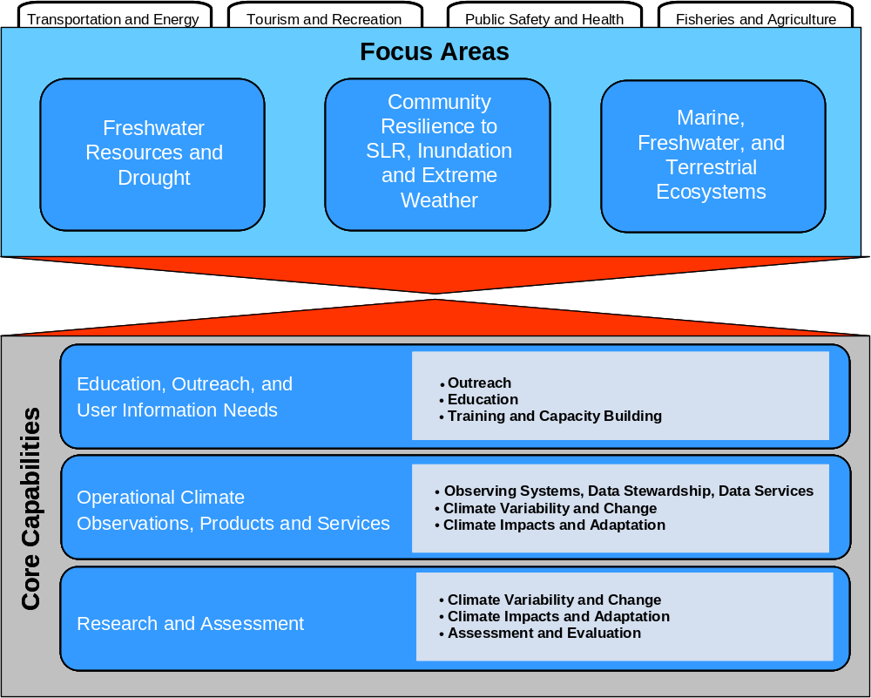

Figure 2. The PaCIS Climate Services System Architecture. This figure depicts the elements that define the PaCIS programmatic framework. At the top are the issue-based focus areas that drive end-user product and service requirements in terms of content, format, and time frame. Above this are examples of decision-based sectors that cut across the focus areas. At the bottom are the core capabilities that are engaged to generate operational products and services. At the center of the figure is the connection between the focus areas and the core capabilities that occurs through an iterative, two-way dialog among producers and users of climate services.

Programmatic Framework
Core capabilities within the agencies, institutions, and organizations that constitute PaCIS represent an ‘end-to-end’ system of products and services (Figure 2). This includes:
- Outreach, Education, Training and Capacity Building
- Observing Systems, Data Stewardship, and Data Services
- Understanding and Predicting Climate Variability and Change
- Understanding Climate Impacts and Informing Adaptation
- Assessment and Evaluation

Targeting products and services to unique user needs is accomplished through the establishment of focus areas associated with climate issues critical to the region. These focus areas are identified as:
- Preserving Fresh Water Resources and Minimizing the Impacts of Drought
- Fostering Community Resilience to the Impacts of Sea Level Rise (SLR), Coastal Inundation, and Extreme Weather
- Sustaining Marine, Freshwater, and Terrestrial Ecosystems
Focusing on regional issues integrates the core capabilities. It draws upon them in a way that supports the development and delivery of products and services that meet the needs of specific users (such as community planners, resource managers, and the public) so that infrastructure, ecosystems, human health and welfare can be effectively managed. Focusing on sub-regions (e.g., central, western, and south Pacific) is also relevant as it responds to differences that exist among the Pacific Islands in terms of climate drivers, issues, and institutional capacities. This provides for more precise targeting and delivery of products.

Action Areas
Three broad categories of actions represent the foundation upon which the development and delivery of climate services in the Pacific region are based.

I. Building a Network of Networks. No single agency, institution, or organization can provide all of the climate services that the region needs. Recognizing this, PaCIS is by design an amalgam of expertise, experience, and perspective. What is required is an organizational framework and corresponding mechanisms that support sustained two-way dialogs among diverse science, service, and user communities via a ‘network of networks’ as a means to nurture essential partnerships, align complementary interests and activities, and thereby grow a regional culture of communication, coordination and collaboration.

A ‘pearl’ has been used as a metaphor to describe the myriad of networks comprised of communities of scientists, practitioners, and decision-makers intertwined across and through various levels from national and international policy development and program planning to regional and local project development, implementation, and evaluation (Figure 3).

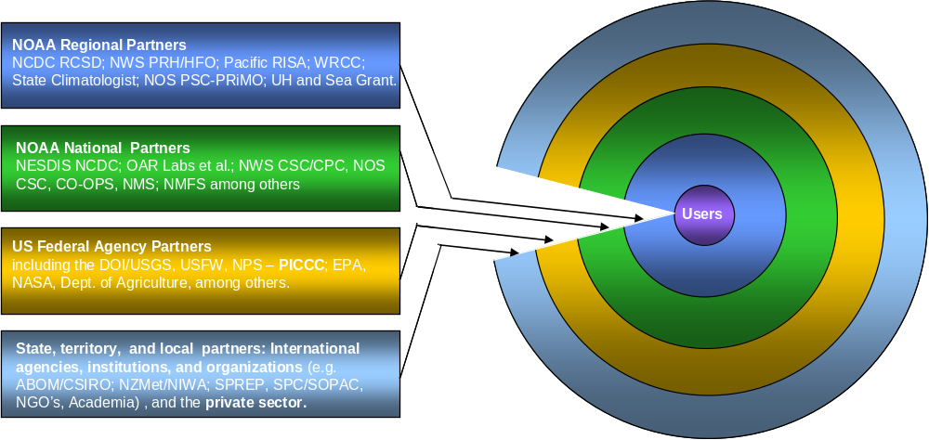

Figure 3. The NOAA Climate Services ‘Pearl’ in the Pacific. Depicted here is the ‘pearl’ specific to NOAA regional climate services in the Pacific. At the center are the users that drive the demand for climate services. Region-specific elements within NOAA and/or associated with NOAA that are actively engaged in climate science and services form an inner layer that wraps around the core. Progressing outward are layers composed of other regional and national elements of NOAA; regional and national elements of other federal agencies; and finally a broad range of non-federal, state, territory, local and international agencies, institutions, and organizations. Extending this metaphor to describe the networks of other agencies, institutions, and organizations -with each forming their own pearl- results in a ‘string of pearls’ that hold the expertise, experience, and perspective required to provide all of the climate services that the region needs and that together makeup PaCIS.
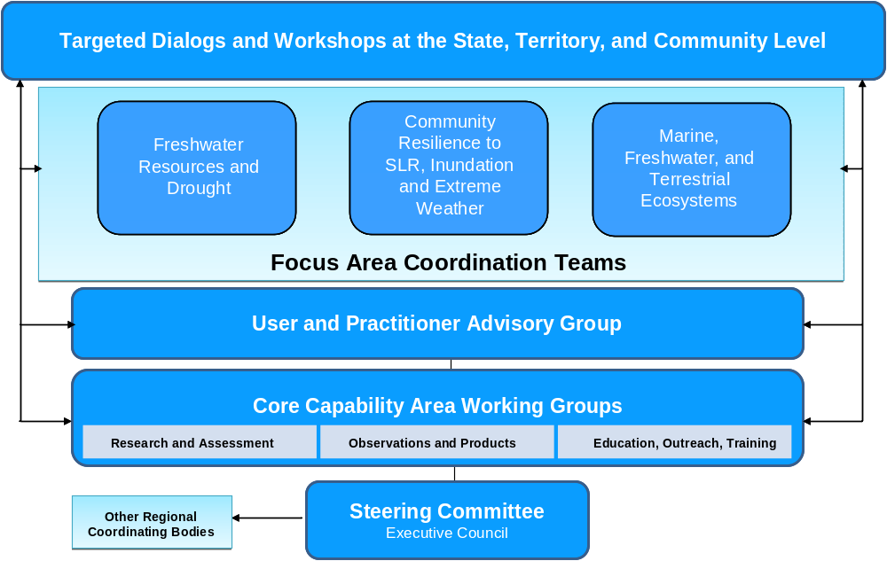

Figure 4. The PaCIS Climate Services Organizational Architecture. Note the placement of the Focus Area Coordination Teams (FACTs) at the center of this figure.

Figure 4 attempts to capture this ‘network of networks’ within an organizational structure. At the top is the diverse array of decision-makers that drive what is an accelerating demand for climate services. This collection of governing and planning bodies, formal and informal groups, and individuals at the regional to community level that spread across an assortment of sectors is an integral part of PaCIS. They are clients for climate services. In this respect, PaCIS’s role is to serve as a medium through which emerging new science and associated capabilities is transmitted to, and conversely through which their needs (e.g., content, format, and time frame) are conveyed back to scientists and practitioners.

At the center of the organizational structure are the Focus Area Coordination Teams (FACTs). Consisting of individuals from various agencies, institutions, and organizations leading or overseeing projects and activities that fall within a given focus area and across capability areas, this group is the nexus between science and service. Their role is to coordinate and collaborate in two broad areas – 1) Assessment and 2) Program Planning and Implementation – and in this way maximize the mutual benefits of cooperation by leveraging resources, bridging gaps, and reducing redundancies.

At the bottom of this organizational structure is a set of coordinating and governing bodies. The User and Practitioner Advisory Group is composed of state, territorial, and community-level decision-makers from different sectors within and across the Pacific region. Their primary role is to help evaluate input collected from communications with users regarding needs along with information distributed by scientists and practitioners regarding products and services, and to feed this information to the FACTs, the Core Capability Area Working Groups, and the Steering Committee to help identify and prioritize actions that can be taken to further the development and delivery of climate services. The Core Capability Area Working Groups are, for the most part, composed of university and government researchers and project managers actively engaged in work related to climate services in the Pacific. Many members of this group will serve on the FACTs. However, in contrast to the FACTs, the working group’s role is to look across the three focus areas for connections pertaining to the core capabilities and make action recommendations to the Steering Committee. The Steering Committee consists primarily of program management level or higher representatives from NOAA, other US Federal Government, and corresponding regional and international entities with a stake in climate services. In addition to guidance and oversight, its role includes managing relationships with other regional coordinating bodies, promoting PaCIS at the national and international level, helping to identify and secure resources, setting priorities, and evaluating success. The Executive Council represents a small subset of this group whose role is to facilitate and guide the day-to-day business needed to carry out agreed upon actions and perform the tasks involved in managing a regionally-integrated climate services system.

The FACTs are placed at the center of the organizational structure for emphasis. This placement is intended to reflect their key functional role within PaCIS. This is also evident in Figure 5, where the FACT (blue box) sits at the center of a hub of activities (synonymous with the core capabilities) that need to be orchestrated in order to generate a focus area-related line of operational products and services that meet the requirements of unique sets of decision-makers. These activities, and the role of the FACTs, are considered further below in the context of the other PaCIS action areas.

II. Conducting Assessments as a Sustained Process. The assessment process exemplifies the synergy between science and service. It frames the dialogs among the science, service, and user communities, and as such, is essential to guiding the development and evaluation of operational products, services, and research. An assessment process that incorporates current research and considers user requirements and user feedback by cultivating an approach grounded in the iterative ‘co-production of knowledge’ at multiple levels is required to ensure that science and services are appropriately and effectively brought to bear on relevant problems and questions.

‘Assessment’ is a word applied to a broad range of activities that vary in both purpose and scope. In the context of the PaCIS assessment process, the activities fall into two categories referred to here as climate science assessments and needs and capabilities assessments. Climate science assessments are typically focused on a wide-ranging analysis of current knowledge, or the ‘state of the science’ as interpreted from a broad set of peer-reviewed and open-source material (e.g., U.S. Global Change Research Program, USGCRP; Intergovernmental Panel on Climate Change, IPCC). Correspondingly it is the climate variables, climate-related phenomena or forcings and their related responses or impacts that are of particular interest. Needs and capabilities assessments are typically focused on characterizing the ‘demand’ and ‘supply’ sides of the system. The former tends to be directed at identifying ‘stakeholders' and evaluating their product and services needs, ideally in the context of various sectors (e.g., local/state government, tourism industry, etc). As such, it informs observations, as well as targeted products and services requirements and thereby supports their development. The supply side of the assessment tends to be directed at evaluating the status of or inventorying products and services in the context of the core capabilities. A ‘capacity’ (versus capability) assessment, which evaluates aspects of individual knowledge, skill, interest, attitude and/or abilities relevant to climate and climate issues is also included in this category. Often assessments of needs and capabilities are carried out in conjunction with each other, with the marriage of the two forming the basis of an analysis of the gaps in scientific understanding as well as products and services.

Assessments employ a range of methodologies to collect pertinent information. These include direct one-to-one interviews, focus group discussions, stakeholder workshops, oral and written surveys, the analysis of existing information in reports, papers, or presentations, as well as more formal cost-benefit analysis and/or non-market valuation tools/techniques.

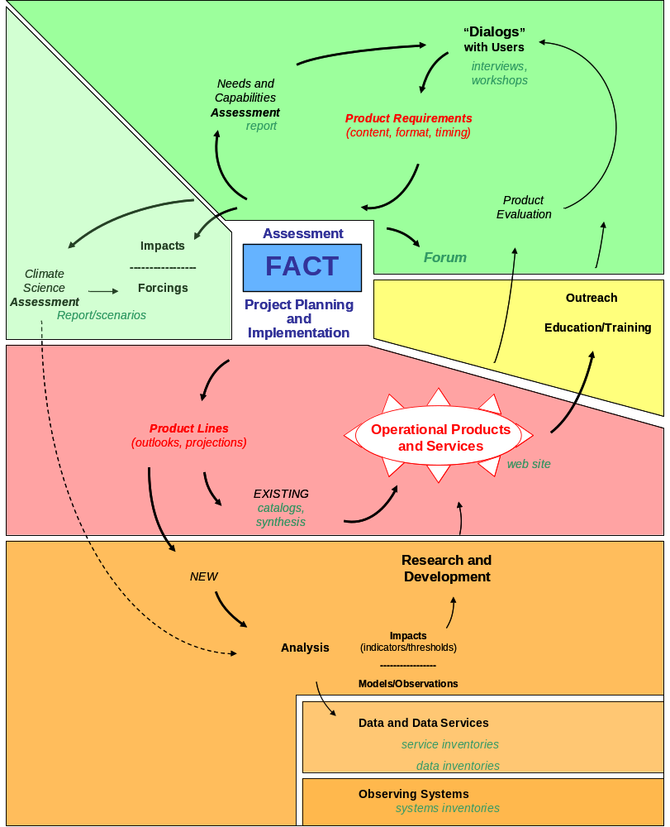

Figure 5. The PaCIS Climate Services Functional Architecture. Note the shaded areas, which encompass related sets of activities and outputs: Assessment (in green); Research and Development (in orange); Operational Products and Services (in red); and Outreach, Education and Training (in yellow). Note also the relationships within and between them, as depicted by the arrows. Together they constitute an iterative process leading to the development and delivery of operational products and services. Finally, note the FACT (in blue) at the center of the diagram as the driver of the process. Each FACT will carry out a similar set of activities and generate comparable outputs; however the combinations of leaders and participants will differ for each FACT depending on the various agency, institution, and organizations mission, interests, and expertise.
That a number of assessments in one form or another are on-going or planned for the Pacific region by a diverse mix of agencies, institutions, and organizations both in and out of the PaCIS family presents a challenge. What is called for is the integration of this network of assessments. This requires both a framework and a process that will enable the various entities conducting assessment to reach across boundaries and work in tandem to harmonize each others approaches and outcomes.

III. Assembling and Advancing Core Capabilities to Develop and Deliver Products and Services Focused on Regional Issues. Making available a collection of information centered on understanding and predicting climate variability and change is a fundamental element of climate services. One such example is seasonal to annual ‘outlooks’ and decadal to multi-decadal projections of key parameters such as rainfall and sea level. This information must be reliable, relevant, timely, and easy to access and use. Beyond this primary level of information is the development and delivery of value-added information targeted at understanding climate impacts and informing adaptation at local and regional levels in a way that meets the needs of specific users (i.e., focus area product lines).

As noted above, creation of a robust and sustained assessment process is essential to guiding the development and evaluation of operational products, services, and research. What follow from the assessment process are gap analyses and alignment exercises intended to inform and guide the various agencies, institutions, and organizations involved in PaCIS as they set priorities and allocate resources in support of coordinated program planning and implementation; a delineation of what constitutes a primary level of products and services associated with the core capability areas and establishing their requirements; and a determination of what value-added products and services are required to address specific issues associated with the focus areas. Examples of the sorts of activities that need to be carried out to develop and deliver products and services include the cataloging and synthesis of existing products and services and the packaging of this information (that includes guidance) for use in regional websites. The formulation of new products and services will need to draw upon research and development (including modeling and analysis). In both cases (existing and new products) delivery must be supported by robust and sustained data collection, stewardship, and services systems. Product delivery will also need to be accompanied by outreach and education, with an emphasis on training and capacity building.

The FACTs will play a central role during the incubation of coordinated program planning and implementation. They will evaluate the status of various science and services aspects of a respective focus area and, bringing to bear the full spectrum of core capabilities, identify actions that can be taken to improve the situation. Embedded in detailed work plans, such actions include the enactment of measures that can be taken to address critical research issues, the preparation of ‘best practices’ guidance, and the creation of particular types of decision-support tools. The FACTs may identify specific projects and activities that represent ‘anchors’ in the context of the regional focus areas and that, as such, elements of other projects and activities can be tied to or built-upon. They may propose plans for joint action in response to requests from users or practitioners.

Priority Actions
Efforts to identify and prioritize actions to further the development and delivery of climate services in the Pacific region are in their formative stages. These efforts will continue, evolving iteratively and involving extensive stakeholder engagement. Efforts to date suggest that, at a minimum, priority needs to be given to actions that: 1) fit well within the PaCIS mission; 2) are most feasible; and 3) have the greatest potential impacts. They also suggest that the actions outlined below within each of the three action areas are among the highest priority over the next 1-2 years. These priority actions are intended to:
- Improve access to and use of existing climate data products and services;
- Enhance our understanding of the climate system and its social and environmental impacts in a way that leads to the creation of new products and tools that can be used to guide and support decision-making;
- Expand the cadre of individuals skilled in understanding the science behind and consequences of a changing climate, and capable of making use of the technical capabilities at their disposal; and
- Broaden and strengthen strategic programs and partnerships across the Pacific.

Build a Network of Networks. Attention will be directed at establishing and maintaining an expanded PaCIS network. This will lay the groundwork needed to integrate activities and leverage resources. Specific outputs in this action area include:
- Modified PaCIS Terms of Reference to include provisions for an Executive Council, Focus Area Coordination Teams, and the User and Practitioner Council and including scope and responsibilities consistent with the intent of the organizational architecture and growth in the number of agencies, institutions, and organizations involved in climate services in the region.
- Formation of an Executive Council to facilitate and guide the day-to-day business.
- Formation of FACTs consisting of a mix of and led by different sets of agency, institution and organization representatives as a primary means to co-evolve and conduct an initial set of assessments and orchestrate joint program planning and implementation leading to the development and delivery of PaCIS focus area product lines.
- Established mechanisms through which the set of advisory, coordinating, and governing bodies can carry out work as needed including: facilitated review of information in reports, presentations, or other such materials; quarterly meetings/conference calls, periodic email or other such digital dialogs; the formation of task groups; and annual meetings and/or targeted workshops, all supported by dedicated PaCIS-member staff.

Conduct Assessments as a Sustained Process. Attention will be directed at employing the PaCIS network to conduct an initial set of assessments and establish an on-going, comprehensive, integrated assessment process. Elements of what constitutes a Pacific Region climate assessment process are depicted in Figure 6. It consists of two phases. The first phase is focused on bringing the research community together to conduct a wide-ranging appraisal of current knowledge – both observed and modeled – as interpreted from a broad set of peer-reviewed, open-source, or other potentially relevant material. So-called consensus workshops would take place around each focus area targeting the Essential Climate Variables (ECV’s) deemed to be relevant to the given focus area. ² Drawing upon the results of the regional science synthesis (as well as the results of assessment efforts that have been recently completed at the national, regional, and local level), the second phase of the assessment is focused on evaluating climate impacts and considering implications to needs, capabilities, and capacities in each focus area and/or sectors (e.g., energy, transportation, agriculture, health, insurance, construction, tourism, and national security). Ideally, this would be carried out through a series of sub-regional climate impact forums that bring together a diverse mix of participants from the research, resource, and user communities to share knowledge and perspectives. Specific outputs in this action area include:
- A series of focus area climate science consensus dialogs or workshops.
- A regional science synthesis report consisting of ‘norms and storms’ synopses and scenarios for each ECV by sub-region.
- At least one climate impacts forum that brings together the diverse science service, and user communities that make up the PaCIS network to engage in a process of collaborative dialog.
- A regional impacts synthesis report consisting of an evaluation of climate impacts, as well as needs and capabilities, by focus area and/or sector for each sub-region.
- A regional climate assessment that synthesizes the results of the above into an integrated document or other such materials as appropriate.

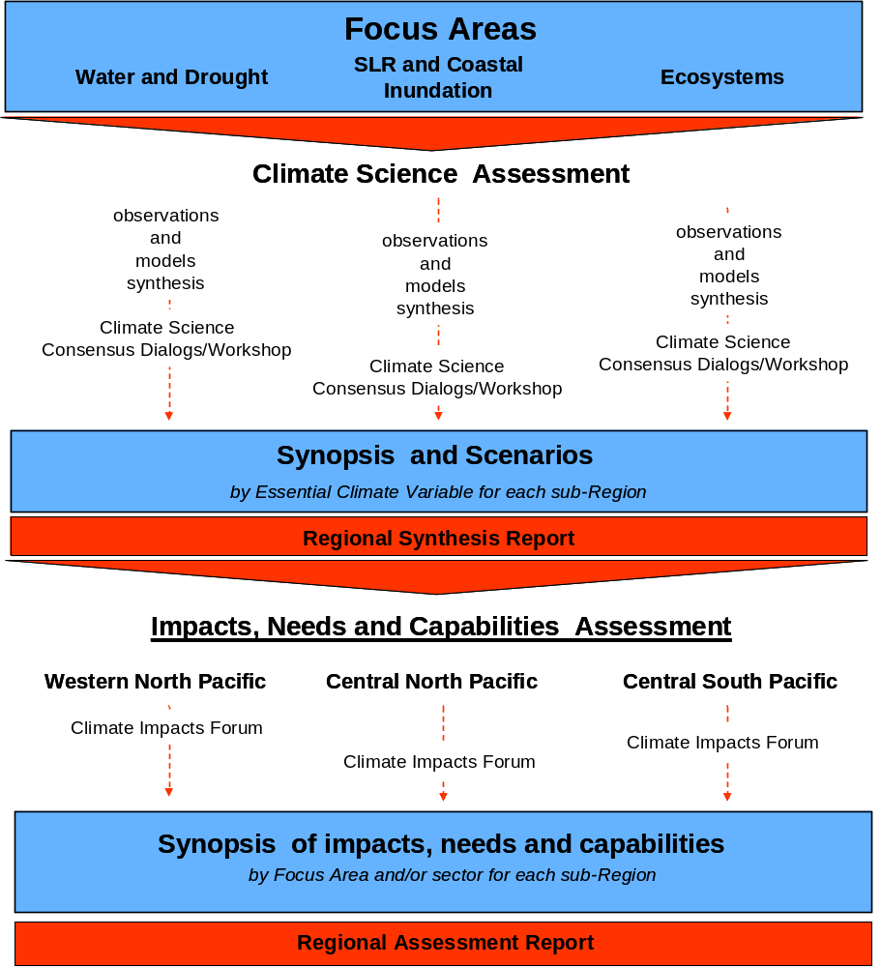

Figure 6. The PaCIS Assessment Process. This figure depicts the assessment process as having two phases. The first is designed to generate a synthesis of the ‘state of the science’ by Essential Climate Variables through consensus dialogs or workshops in each of the focus area. The second phase is designed to generate a synopsis of climate impacts by focus area and/or sector, and in that context identify needs, capabilities, and capacities. Ideally, this would be carried out through a series of sub-regional climate impact forums.

Assemble and Advance Core Capabilities to Develop and Deliver Products and Services Focused on Regional Issues. Attention will be directed at conducting projects and activities within and between the core capability areas that lead to the development and delivery of products and services that meet issue-specific needs. This will range from the packaging of existing primary level information centered on understanding and predicting climate variability and change to the creation of new value-added information targeted at understanding climate impacts and informing adaptation. Specific outputs in this action area include:
- A gap analysis and subsequent alignment and program and project planning exercise across the core capability areas culminating in a detailed work plan for each focus area.
- A regional web portal that provides access to a broad range of information including summaries of regional programs, projects and activities, and assessments, as well as outreach-related materials such as fact sheets and climate impact and associated adaptation case studies.
- A web-based inventory of/guide to existing regional data by ECV, and station/platform type (i.e., in-situ versus remotely-sensed).
- A survey and assessment of regional observing assets by ECV with an initial focus on rainfall and sea level.
- Regional plans for the collection, management, recovery, and delivery of ‘climate quality’ data with an initial focus on rainfall and sea level.
- A web-based climatology atlas that integrates existing products describing historical ‘norms and storms’ of ECV’s such as air temperature, rainfall, and sea level.
- A web-based catalog of existing regional seasonal outlooks and multi-decadal projections by ECV and/or focus area with an initial emphasis on rainfall, sea level, and sea surface temperature.
- A synthesis of regional operational outlooks and scenarios leading to the development of applications guidance with an initial emphasis on rainfall, sea level, and sea surface temperature.
- New enhanced outlooks that target sub-regions and/or specific sectors.
- Support for climate model down-scaling and coupled climate models towards the creation of a regional model ‘test bed’.
- Identification of data that is ecologically and socially relevant with respect to diagnosing ‘climate sensitivity’ (i.e., so-called indicators and thresholds).
- A web-based catalog of issue-related regional products, including climate change visualization and decision-support tools that can be used to assess impacts and evaluate adaptation options.
- Climate-related training that includes regionally-relevant and regionally-requested content, as well as content that supports effective K-12 and Higher Education and informal education and outreach activities.

Conclusions
The programmatic framework outlined here is designed to meet the demand from decision-makers in the Pacific Islands for ‘actionable’ information needed to manage risks and support practical decision-making in the context of climate variability and change. The framework:
- Takes a comprehensive, integrated approach to the development and delivery of climate services.
- Promotes a shared understanding between and among information providers and users of the nature of the problems and needs, and thereby enables the unique information requirements of users in the Pacific Islands to be better articulated and information products better designed to address those requirements.
- Provides a structure for bridging gaps and eliminating overlaps, as the various agencies, institutions, and organizations involved in climate services are better able to understand where they can best fit and contribute, improving efficiency and effectiveness.
- Represents a holistic view based on recognition of the benefits of collective vision and action to achieve short and long-term goals that would otherwise not be attainable as individuals or entities working independently.

Implementing the framework will require commitment to an iterative, nested, collaborative and participatory process of program planning and product development. The utility of the framework will be evaluated and refined through such dialog.
Achieving the specific outputs identified here will require adequate fiscal and dedicated human resources. Leads for the multiple and complex actions that need to be carried out to achieve the outputs identified above will vary depending on respective mission, interests, and expertise. Effective coordination of activities among partners and stakeholders that includes a balancing of agency, institution, and organization portfolios will be required. This is already happening.
- In the water resources and drought focus area the Pacific Regional Integrated Science and Assessment (PacificRISA), the United States Geological Survey (USGS), and the University of Hawaii (UH) are working together.
- In the community resilience to sea level rise and coastal inundation focus area the NOAA National Climatic Data Center (NCDC) and National Ocean Service (NOS) through the CO-OPS, the CSC Coastal Storms Program for the Pacific Region, and the Pacific Services Center (PSC) are working with UH and the University of Hawaii Sea Grant College Program.
- In the marine, freshwater and terrestrial ecosystems focus area the NOAA National Marine Sanctuaries (NMS), National Marine Fisheries Service (NMFS), the United States Fish and Wildlife Service (FWS) and National Parks Service (NPS) are working with and through Pacific Islands Climate Change Cooperative (PICCC).
- In the context of the Observing Systems, Data Stewardship, and Data Services core capability area, among those playing important roles are the NOAA NCDC and National Weather Service (NWS), the Western Regional Climate Center (WRCC); the Hawaii State Climatologist, the USGS, the U.S. National Aeronautics and Space Administration (NASA), the Pacific Regional Environment Programme (SPREP), the Secretariat of the Pacific Community (SPC) Applied Geoscience and Technology Division (SOPAC) and affiliated Pacific Island-Global Climate Observing System (PI-GCOS) and Pacific Island-Gobal Ocean Observing System (PI-GOOS) programs and the Pacific Disaster Center (PDC).

¹Restructuring Federal Climate Research to Meet the Challenges of Climate Change. The National Academies Press, Washington, DC, 13. 5NRC (V. Ramanathan Chair), 2009

² GCOS Essential Climate Variables http://www.wmo.int/pages/prog/gcos/index.php?name=EssentialClimateVariables

